Welcomes to Montreal Guest Instructor
Sensei Don Sharp, 6th Dan
from Valley Shidokan dojo, Chilliwack, British Columbia.

Monday, September 28 /2015 – Sunday, October 4th, 2015

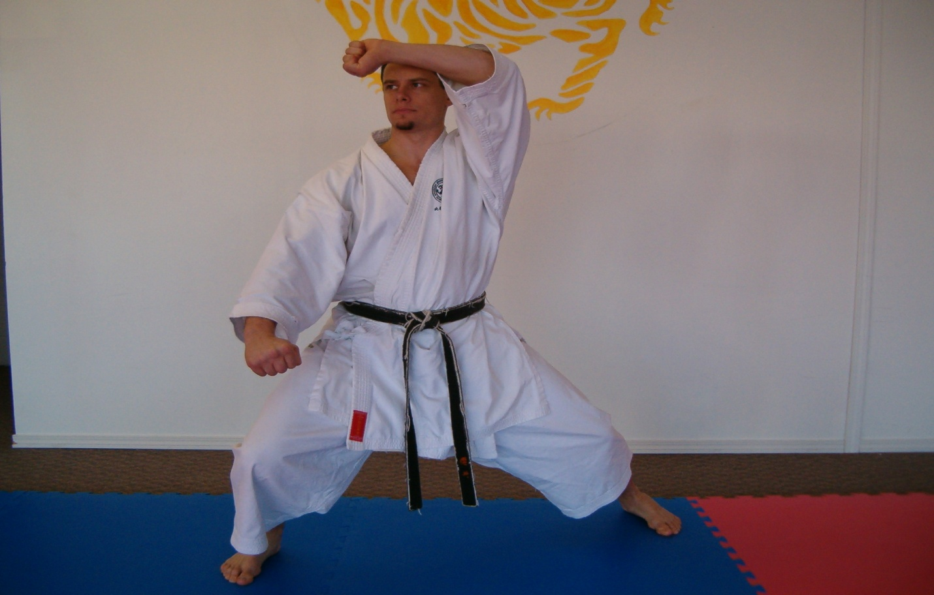
Don Sharp 6th Dan

Sept 10, 2015,

Dear Karatekas,
We are proud to announce the 2015 Eastern Canada JKA Gasshuku, with guest JKA instructor Sensei Don Sharp, 6th Dan from Chilliwack, British Columbia. You will find attached a biography on Sensei Don Sharp prepared by one of his students.
The event will be held from Monday, September 28 to Sunday, October 4, 2015.
During this period, Sensei Don Sharp will be visiting the following dojos: Kirkland JKA, Notre Dame du Laus JKA-Sakurai Dojo, Westmount JKA, Shidokan International – Kangeiko & Concordia University dojo, Côte St Luc JKA & Nuns’ Island JKA.

This is a great opportunity for us to train together with Sensei Don Sharp, as well as other instructors and karatekas at the host dojos.
Please find below the Gasshuku schedule and addresses of the host dojos, as well as the participation fees.
For any additional information regarding locations of host dojos, please call or email the contact information shown in the schedule below.
If you are a member of one of the host dojos, you must register with your dojo. If you are Not a member of one of the host dojos, please register at the dojo where you are attending the class(es)
Let’s all train together and make this a successful event.

Host Dojo, Instructors

The Secret is in the Training

Schedule
Date | Host Dojo Location | Time | Level (Belts) | Instructors
Mon, Sept 28 /15 | Concordia University Dojo  Le Gym  1515 St Catherine st W.  Room S2.02  Metro Guy-Concordia | 18:15 – 19:15 | Yellow - Black  Adults only | Melarie Taylor, 5th Dan  514 735 4389  melarietaylor55@gmail.com
Tue,  Sept 29 /15  Wed, Sept 30 /15 | Kirkland JKA  Kirkland Arena  16950 Hymus  Kirkland, H9H 3W7  Kangeiko dojo  Decarie Square  M Fitness  6900 Decarie  2nd floor, Montreal  Entrance from underground parking garage. | 18:00 – 19:00  19:00 – 20:00  6:00-7:00 | All levels  Green-black  All ages  Black Belts  Adults only | Mark Deschatelets, 5th Dan  514 214 7180  mdeschatelets@traffictech.com  Angelo Massotti, 5th Dan  514 299 6354  unitedbrokersqc@gmail.com  Francois Gelinas, 6th Dan  Melarie Taylor, 5th Dan  514 735 4389  melarietaylor55@gmail.com
Wed, Sept 30 /15 | Westmount JKA  Westmount Community center  4675 St Catherine st. w  Westmount, H3Z 1S4 | 18:45-19:45 | All Levels  All ages | Ashraf Ismail, 4th Dan  David Pinchuk, 4th Dan  Rosanna Eugeni, 3rd Dan  rosanna@westmountjka.com  514 941 1962 (David)
Thurs, Oct 1/15 | Kirkland JKA  Kirkland arena  16950 Hymus  Kirkland, H9H 3W7 | 18:00-19:00  19:00-20:00 | All levels  Green-black  All ages | Mark Deschatelets, 5th Dan  514 214 7180  mdeschatelets@traffictech.com  Angelo Massotti, 5th Dan  514 299 6354  unitedbrokersqc@gmail.com
Fri,  Oct 2/15 | Côte St Luc JKA  West End Gym  7025 Côte St Luc rd  Downstairs | 18:00-19:00  19:00-20:00  20:00-21:00 | Yellow- Green  Blue-brown  Black belts  All ages | Stacy Ungar, 5th Dan  514 487 7839  Stacy.ungar@sympatico.ca
Sat,  Oct 3/15 | Nuns’ Island JKA  300 chemin du Golf  Nuns’ Island  H9J 4c3 | 10h00-11h00  11h00-12h00 | All levels  Brown – Black  All ages | Sharhokh Hoghooghi, 6th Dan  514 909 9089  nunsisland@canadajka.ca
Sun,  Oct 4/15 | Notre Dame du Laus JKA  Sakurai Dojo  4 rue de l eglise  Notre Dame du Laus, QC, J0X 2M0 | 10h30 -12h00 | All Levels.  All ages | Mark Deschatelets, 5th Dan  819 767 2893  mdeschatelets@traffictech.com

Participation Fees
Full Camp Cost & # of classes | Half Camp Cost & # of classes | Per class Cost
$30 White / 5 classes  $50 Yellow - Orange / 6 classes  $70 Green - Blue / 9 classes  $80 Brown / 10 classes  $90 Black / 11 classes | $20 White / 3 classes  $30 Yellow – Orange / 4 classes  $45 Green - Blue / 5 classes  $45 Brown / 6 classes  $60 Black / 6 classes | $15 White  $15 yellow - Orange  $20 Green - Blue  $25 Brown  $30 Black

Participating Host dojos Instructors

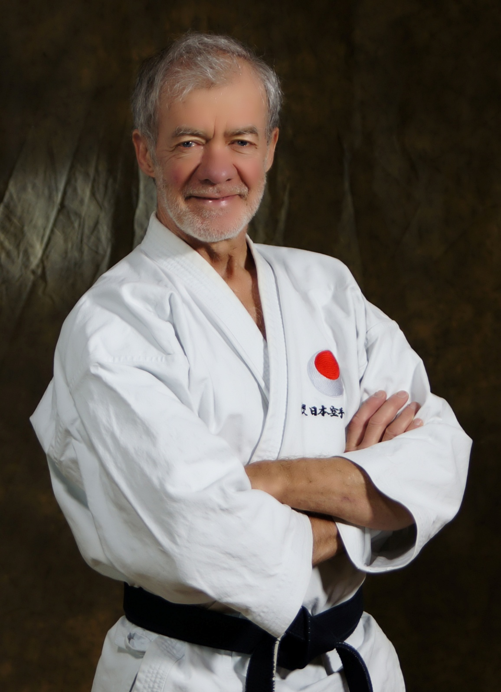
Francois Gelinas 6th Dan
Pioneer of Karate in Quebec
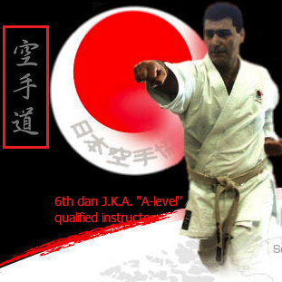
Shahrokh Hoghooghi, 6th Dan

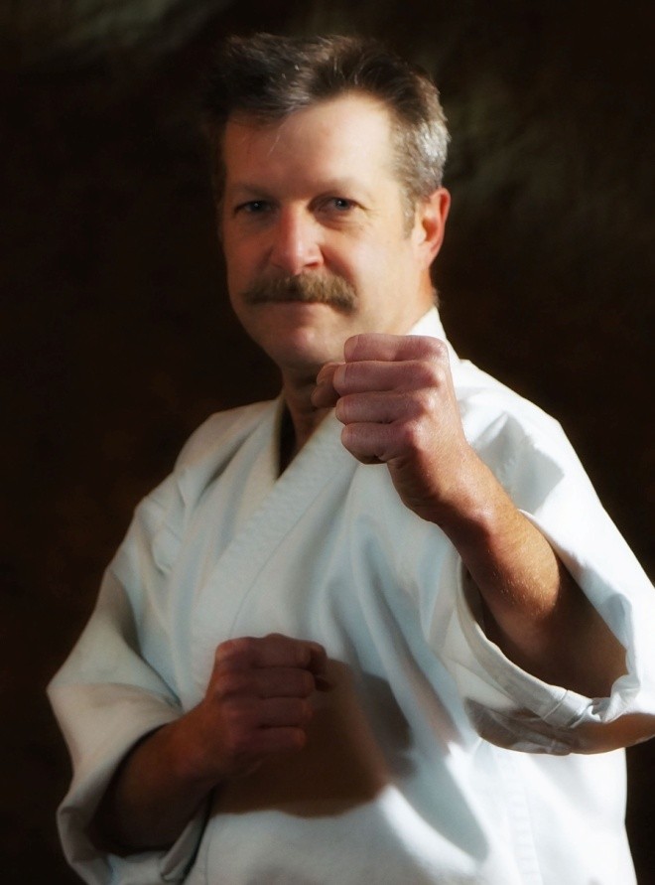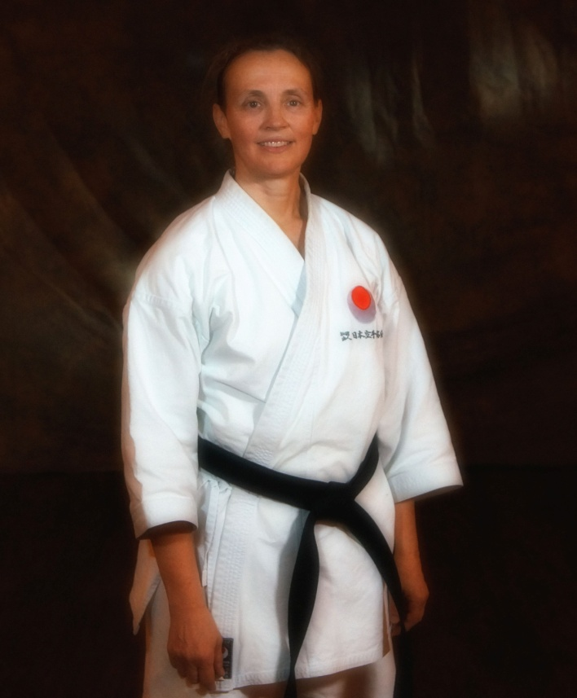
Mark Deschatelets, 5th Dan Melarie Taylor, 5th Dan
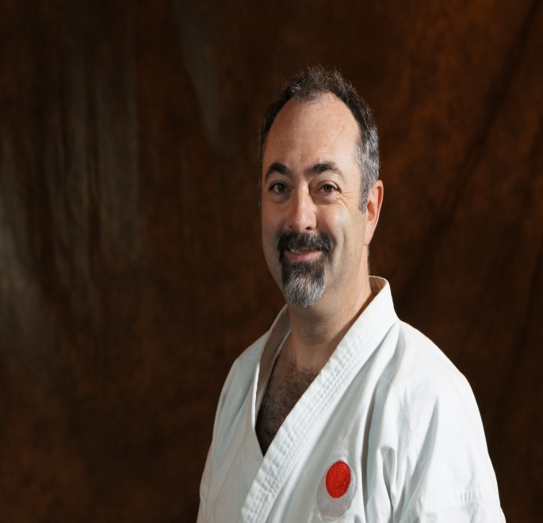
Angelo Massotti, 5th Dan

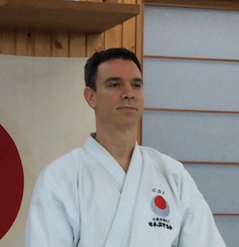
Stacy Ungar, 5th Dan

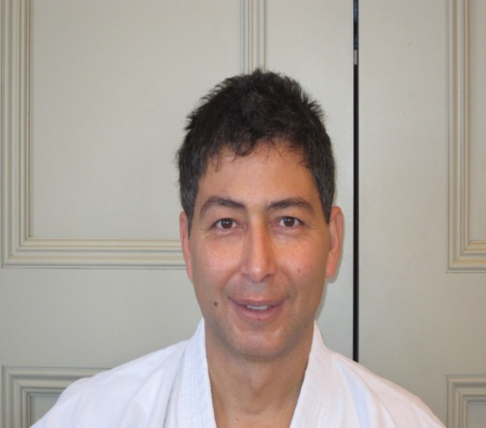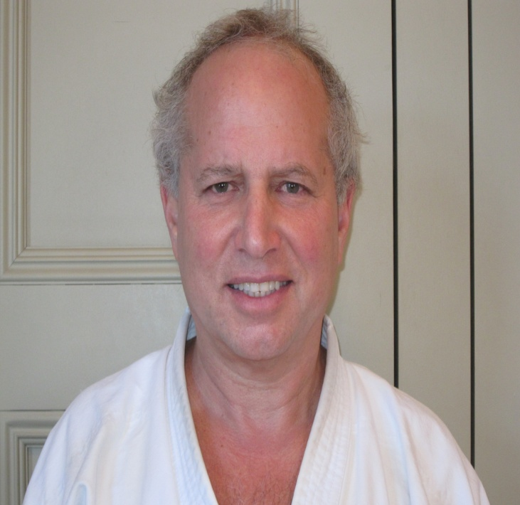
Ashraf Ismail, 4th Dan Dave Pinchuk, 4th Dan

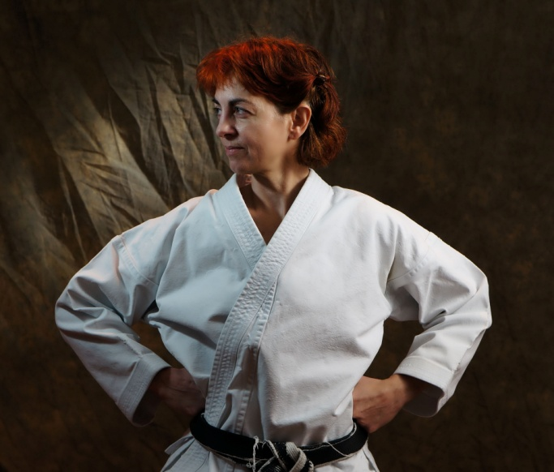
Rosanna Eugeni, 3rd Dan

The following is a biography prepared by one of Sensei Don’s students.

My Instructor, Don Sharp
Many of us know how lucky we are to be training with Sensei Don sharp, because of his great teaching ability, his character, his enthusiasm and tremendous expertise of our art…. But I think many of our members have no clue how truly accomplished our instructor is. Don Sharp being so modest we just don’t often hear of his own accomplishments. So I am writing this biography in hopes that our members will know a little more of our instructor and really get a feel for how fortunate we are.

Don Sharp started training in JUDO at the age of 9. He had already fallen in love with the martial arts and that was his option at the time. He trained very hard and even at that age was noticed by his Sensei’s , Ken Earhart and Dave Jones. Unfortunately the club folded after Don had trained there for a couple of years and had gotten his 3rd Kyu. He continued training under Ken Earhart and still keeps a relationship with Mr. Earhart to this day, over 30 years later. Don saw a Karate club training at the local “Y” and was instantly captured!!! He started right way, under his first Sensei Rob Gale. He trained hard and got to 4th kyu very quickly for a young boy, and then he met Sakurai Sensei!!! Don still talks about that first meeting and training with Sakurai Sensei as a remarkable time of his life and eye opener on what martial arts had to offer. Not just how to kick and punch, but a way of life, a balance of physical, mental, technical and even spiritual way of developing ones growth.
He continued to train under Rob Gale until Sensei Rob Gale turned to Don and asked him if he would take over the Dojo! He was only 18 at the time and had just passed his Shodan a couple of months before under Nishiyama Sensei and Sakurai Sensei. He, of course accepted and he then became the chief instructor of the Chilliwack club. He knew he needed to continue his training as much as he had always even though he was now responsible for teaching the members of the club, so he would drive to Abbotsford to train with Rob Sidoli and all the way to Vancouver to train with Sakurai Sensei. He would always say, ”one who wishes to be a worthy teacher must always continue to be a student. I don’t want to be one of those Sensei’s with my fingers in my belt pointing to my students to do this better or that faster, without making a move myself”. His Dojo quickly gained respect and notoriety with Don going on to Nidan at only 20 years of age, and himself and many of his Dojo members already showing signs of success at tournaments. He was one of the founding fathers of NASKA as a brown belt at 16 year old, and throughout his career has always been a great advocate of Sakurai Sensei’s and of NASKA. He is considered by many to be the most well rounded Karate instructor in Canada. As a competitor he is considered one of the most successful Canadian athletes of all time in Karate.

His accolades

Competition-

Provincial competition
Over 45 medals in provincial competition, including 29 gold medals
A total of approx. 200 medals from local, Provincial, National and International tournaments. Awarded provincial athlete of the year 4 times!

National Competition
11 times national Kumite champion, 5 NKA titles and 6 JKA titles.
5 times medallist in national level kata competition
*Awarded Canadian athlete of the year twice!

Highlights of national level
1995 Nationals- Gold medal open weight kumite, Silver Heavy weight kumite, Gold medal team kumite, ATHLETE OF THE YEAR AWARD, NATIONAL, and SPIRIT OF KARATE-DO AWARD.

1997 Nationals- Heavy weight Kumite Gold medal, open weight bronze, Kata silver, and team kumite silver ATHLETE OF THE YEAR AWARD NATIONAL

1999 Nationals- Heavy weight kumite Gold, Kata silver, team kumite Bronze, (open weight injury, DNF)

1996- JKA nationals Gold kumite, Silver Kata, bronze team kata, and Gold team kumite.

International competition
1996- JKA WORLD CHAMPION, Gold medallist kumite, Osaka Japan

1995- WKF silver medallist Pan Am Championships, Lima Peru

1999- Pan Am Games- fourth place

5 other top 5, or better finishes in world level events of both WKF and JKA events

Coaching

Captain of 2 WKF world cup teams, and 3 World JKA Shoto Cup teams

B.C. Team Coach 3 times.

World Shoto Cup team assistant coach twice

Other accolades

Don Sharp has received a ‘LETTER OF ACCOMPLISHMENT “, from the Prime Minister of Canada, Jean Chretien, and 3 letters from provincial premiers

He received the B.C. premieres Award of excellence in athletics, and was in the B.C sports hall of fame for the year of 2000.

He is presently on the board of JKA-SKD, on the technical committee of JKA SKD Canada, and Technical chairman of JKA-BC

Don Sharp has gotten his JKA instructors course level “A” in international refereeing, "A" instructing and level “B” examining. As well, he has his special JKA rights for Nidan exams as well as D level instructors course exams.

He passed his Rokudan (6th degree black belt) in October of 2011. He did this at the World JKA headquarters (honbu Dojo) in Tokyo Japan. (A very rare occurrence for a foreigner even being allowed to grade let alone passing at the prestigious headquarters grading. He was graded under the most senior ranked instructors in the world, including the JKA World chief instructor, Ueki Shunzeki Shihan

Received 3 National Athlete of the year awards and 4 Provincial awards.

